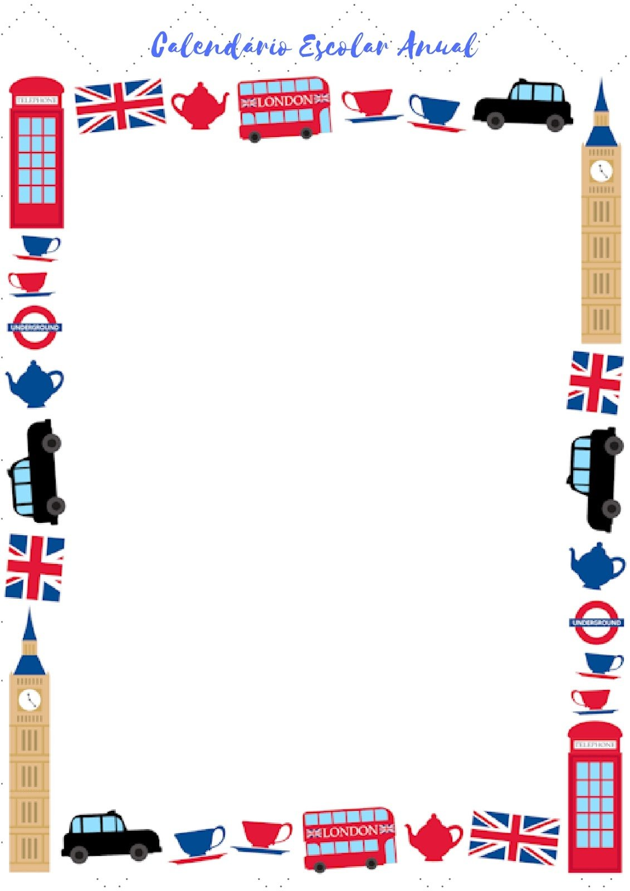**Change this direct speech into reported speech.**

1. “He works in a bank”

She said ___________________________________________________________

2. “We went out last night”

She told me________________________________________________________

3. “I’m coming!”

She said ___________________________________________________________

4. “I was waiting for the bus when he arrived”

She told me ________________________________________________________

5. “ I’d never been there before”

She said ___________________________________________________________

6. “I didn’t go to the party”

She told me ________________________________________________________

7. “Lucy’ll come later”

She said ___________________________________________________________

8. “He hasn’t eaten breakfast”

She told me ________________________________________________________

9. “I can help you tomorrow”

She said ___________________________________________________________

10. “You should go to bed early”

She told me ________________________________________________________

11. “I don’t like chocolate”

She told me ________________________________________________________

12. “I won’t see you tomorrow”

She said ___________________________________________________________

13. “She’s living in Paris for a few months”

She said ___________________________________________________________

14. “I visited my parents at the weekend”

She told me ________________________________________________________

15. “She hasn’t eaten sushi before”

She said ___________________________________________________________

16. “I hadn’t travelled by underground before I came to London”

She said ___________________________________________________________

17. “They would help if they could”

She said ___________________________________________________________

18. “I’ll do the washing-up later”

She told me ________________________________________________________

19. “He could read when he was three”

She said ___________________________________________________________

20. “I was sleeping when Julie called”

She said ___________________________________________________________

**People made these statements. Report them, using said.**

a. “Mary worked in a bank”, Jane said. ____________________________________________________

b. “I’m staying with some friends”, Jim said. _______________________________________________

c. “I’ve never been to Russia”, Mike said. _________________________________________________

d. “Tom can’t use a computer”, Ella said. _________________________________________________

e. “Everybody must try to do their best”, Jill said. __________________________________________

f. “Jane may move to a new flat”, Rachel said. ____________________________________________

g. “I’ll stay at home on Sunday”, Bill said. _________________________________________________